

CSC 1100

**ELEMENTS OF PROGRAMMING**

(Section 4)

SEMESTER 2 2018/2019

LECTURER’S NAME: DR. SURIANI BT. SULAIMAN

**REPORT**

|  |  |
| --- | --- |
| NAME | MATRIC NO. |
| BEN DAIA MOUNIR | 1815105 |
| Abubakar Abubakar Yusif | 1821881 |
| Mouhamad | 1718769 |
| Elhadj Mamadou Alpha Barry | 1719211 |

**Introduction**

This project develop a program that support a laundry service system. The program is design to support the laundry system, this program consist of 2 major operations (1. washing 2. drying). the user is only allows the use only one operation at a time. if the user attempt to enter more than one operation the program will return him/her to the last step. The program will then calculate the total money and the total time used.

At the end of the program the user will see his/her receipt. which consist of the total money and time used by the customer.

**The flowchart:**

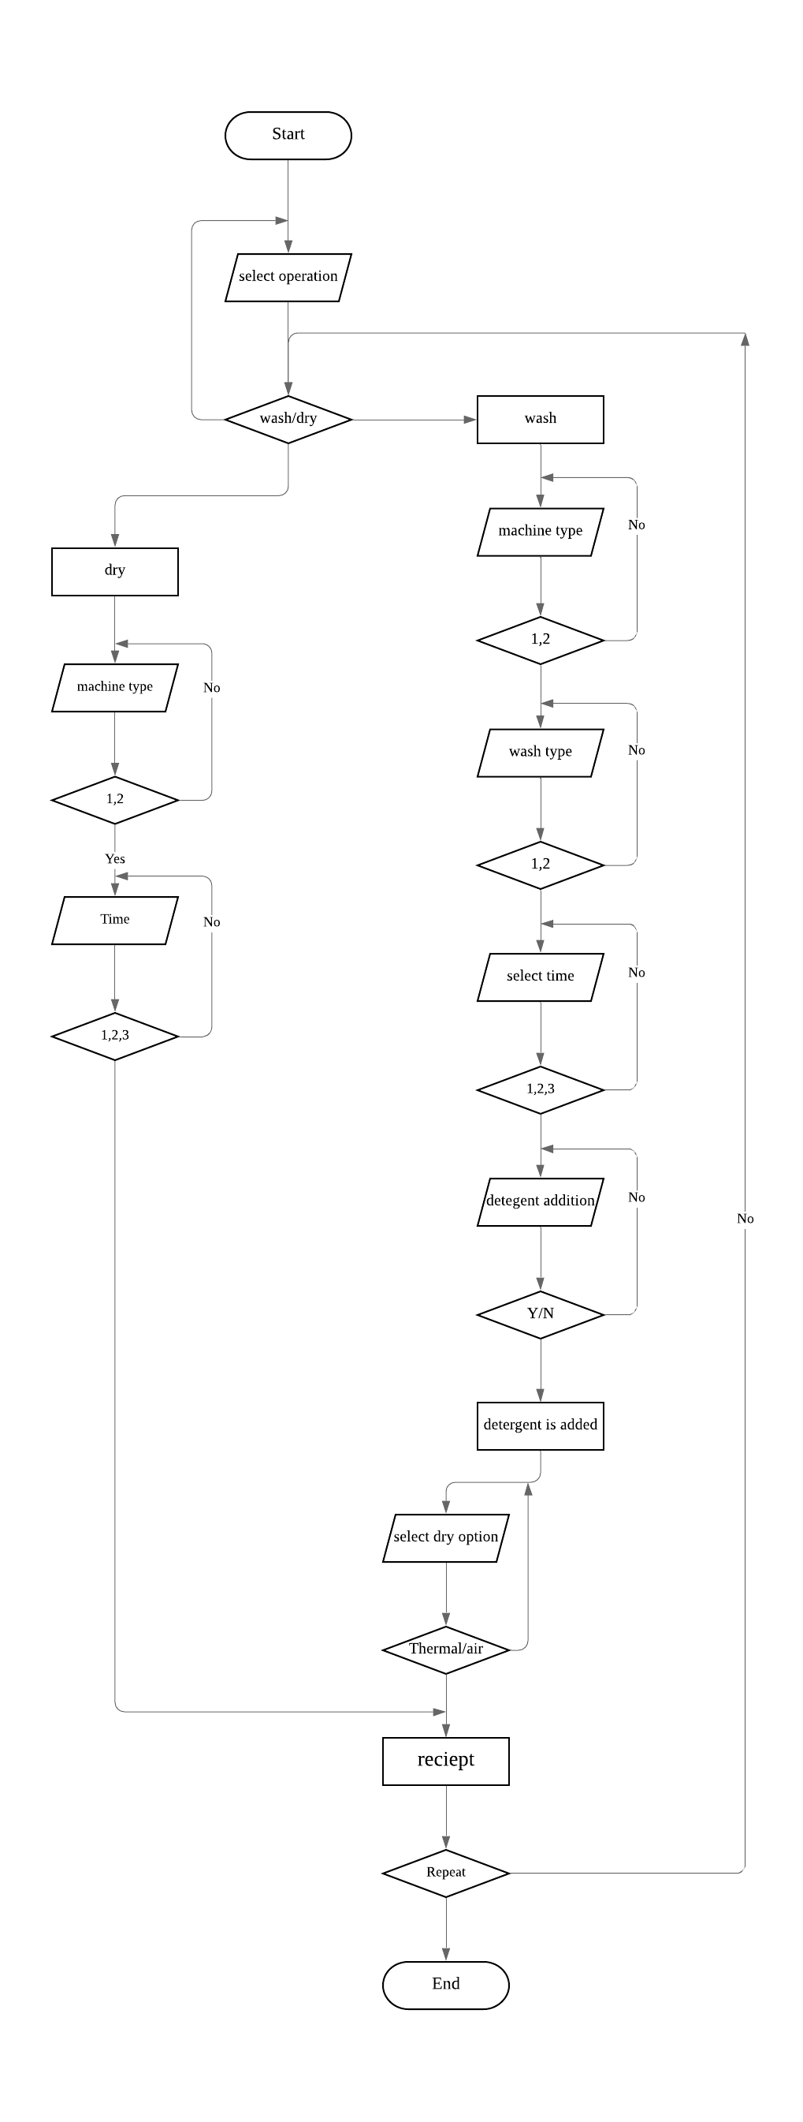

**PROGRAM FUNCTIONS used in the program:**

# Structs:

struct wash

{

int *pntr;

int add;

char complete, answ_add;

};

We use the structs tells the compiler that we are defining a struct named wash. The wash struct contains four variables inside of it: a int named pntr, an int named add, and a char named complete, and char named answ_add.

Void function:

void tags(){

cout<<"========================================="<<endl;

};

When a program begins running, the system calls the main() function, that is, the system starts executing codes from main() function.

When control of the program reaches to tags(); inside main(), it moves to void tags() and all codes inside tags()is executed.

Then, control of the program moves back to the main function where the code after the call to the tags() is executed as shown in figure above.

Arrays

string typ[typewash]={": Warm",": Hot",": Cold",": dryer"};

if (type_wash == "1") {

cout << typ[0] << endl;

}

else if (type_wash == "2"){

cout << typ[1] << endl;

}

else if (type_wash == "3"){

cout << *(typ+2) << endl;

};

if (operation == "2"){

cout << *(typ+3) << endl;

}

in the header file we use array named:typ with size:4 type:string this array contain 4 elements ( :Warm, :Hot,: Cold,: dryer ) .we accessed to the array using 2 methods, the first one is by using typ[0] ,the second one is by using pointers *(typ+2) .

Void function & header file:

void summery(){

string typ[typewash]={": Warm",": Hot",": Cold",": dryer"};

Sleep(2 * 1000);

cout << "==============================" << endl;

cout << endl << setw(17) << left << "Machine Type";

if(type =="1"){

cout << ": Normal" << endl; }

else if (type =="2"){

cout << ": Large" << endl; }

if(operation =="1"){

cout << setw(17) << left << "Wash Type"; }

else if(operation =="2"){

cout << setw(17) << left << "dryer type"; };

if (type_wash == "1"){

cout << typ[0] << endl; }

else if (type_wash == "2"){

cout << typ[1] << endl; }

else if (type_wash == "3"){

cout << *(typ+2) << endl; };

if (operation == "2"){

cout << *(typ+3) << endl; }

cout << setw(17) << left << "Service Time";

if (standar_ret == "1"){

cout << ": 30 Minutes" << endl; }

else if(standar_ret == "2"){

cout << ": 20 Minutes" << endl; }

else if (standar_ret == "3"){

cout << ": 10 Minutes" << endl; }

cout << setw(17) << left << "Total Price" << ": RM" << price<< endl ;

token=price * 2;

cout << setw(17) << left << "Number of Token" << ": " << token << endl<< endl;

cout << "==============================" << endl;

}

in the header file we use void function the function named summery When control of the program reaches to summery(); inside main(), it moves to void summery() and all codes inside summery()is executed.Then, control of the program moves back to the main function where the code after the call to summery().

**Pointers declaration:**

|  |
| --- |
| wash wash;  wash.pntr= &wash.add; // POINTERS  *wash.pntr = wash.add; // DECLARATION OF POINTERS  do  {  if (*wash.pntr == 1){  // Sleep(400);  cout << endl << "Thermal Dryer Selected!" << endl << endl;  break;  }  else if (*wash.pntr == 2){  // Sleep(400);  cout << endl << "Air Dryer Selected" << endl << endl;  break;  }  else{  // Sleep(400);  cout << "\nInvalid Input! " << endl  << "Please Try again: " << endl;  cin >> *wash.pntr;  }  } while (*wash.pntr != 1 || *wash.pntr != 2);  price +=*wash.pntr*2;  } |

Future more, we used pointers in the program . Where by above is the declaration of the pointers and the specific place they used in this program.

**SAMPLE OF SCREENSHOTS for the program:**

